

**Application Portfolio Domo Report**

**Abstract**

I started my Coop internship at Kinaxis in October 2020 as a Business Analyst CO-OP. It was an 8-week CO-OP, but in such a short span of time I learned a lot from the Business Analysts and manager I worked with. `This internship has helped me in enhancing my technical as well as soft skills. I learned new skills such as creating Business intelligence reporting in Domo by creating application portfolio report, managing data in SharePoint, coordinating with the Business Analyst and communicating with them by arranging regular meetings on MS Teams, performing UAT testing and assisting project manager by managing risk and issues for a project.

1. ***Overview***

Application portfolio is the collection of information pertaining to more than 145 applications in the form of SharePoint list. The idea is to leverage the potential of Business Intelligence by gathering the data and creating a domo report which can be used to represent the missing information about these applications which was not documented previously at one place, it can be used by managers to take significant business decisions in the future. In the Domo report, there are two pages The two pages can be used simultaneously by the business managers to analyze and draw key business insights regarding the applications at Kinaxis.

The process of creating the Domo report is consummated into three steps, Data Gathering, Data updating on SharePoint and Creating pages in Domo:

* 1. Data Gathering: The data has been gathered for the existing Application Portfolio webpage, while the Financial data about applications is provided by the IT team.

For the Application Portfolio data, the process involves regular communication with the application owners, which ranges from sending emails and asking for the information or proposing meeting invites on the MS Teams to discuss about the information required to be filled by them in order to complete the Application Portfolio list. Most of the applications have an app owner, there are 15 app owners or more whose are responsible for providing the data about the applications while working on this report. The information from the app owners is recorded in the excel file.

* 1. Updating SharePoint List: The collected information from the application owners is first recorded in an excel file, which is used as a reference to update the SharePoint List. It is a crucial process to update the data online as any inactiveness will resulted into compromising the quality of Domo report.
  2. Creating Domo Report: Once the Application Portfolio data is updated on the SharePoint then it is imported into Domo and an excel file of Financial data by applications is also imported into Domo to create cards which are moved to the pages. These pages/ dashboards are used by the Business managers to make analysis.

In order to create a report in Domo. The first step is to connect the database to the domo. The project has used two data sets, Application Portfolio and Financial Data by applications Jan-Nov. Application Portfolio is a SharePoint list which is managed online. Domo has the potential to import online data using connector and updates it automatically whenever the data is updated on the hosted site. The “SharePoint online” connector is used to import the dataset from the SharePoint list.

* In the Domo header, a tab called Data is selected followed by Cloud API tab. This tab opens a grid view of various online connectors.
* Search for Microsoft SharePoint online connector, once the SharePoint online connector is found, select it and navigate to next page where it is required to click on the button called “get the data”.
* There will be four Div tags appeared on the next page namely, credentials, details, scheduling and Name and Describe your dataset. In the credential tab, the user is supposed to provide his domo credentials along with the link of the hosting site he wishes the domo to import data from. Next is the Details, where a user is required to select “list item columns” from the drop down list under the report label. Following the report label is the list title then check the “Get Display names” checkbox which provides the names of columns as it is displayed in the SharePoint list. Then, select “No Filters (by value)”in the filter columns by label. The Scheduling div has two drop down lists, update interval and update method. The update interval label determines the time to update data in domo when it is updated on the hosting site. For the current project it set to every hour interval. The selected method is “replace” to give the flexibility to the data owner to replace the present data set if required in the near future.
* Save the appropriate options for the given labels and the data will be imported to the Domo successfully. It is depicted in the fig1.0.

The second dataset has been imported by an excel workbook which has many worksheets in it. Following are the steps to import data from excel file and replacing the previous dataset with the updated one:

* In the Datasets header, there is a label called file. Select file and browse the excel file from the local system. Complete the mandatory information and save the data set.
* While updating a new data set with the old one, go to settings of the previous data set. It requires to upload a new data set in details label, Fig 3.
* Once data is imported from the local machine, select the worksheet from the drop down list in the Select tables and click next.
* Then, click on the update mode and select the update method as replace. A preview of data becomes available.
* Compare the two data set, one that was already uploaded by the user and another one which is updated and imported again by following the above steps. If the new dataset imported has all the updated information then, click save and the dataset will be updated.
* Follow the same step every time a new data is available.

1. ***Cards***

Application Portfolio Analysis

Application Portfolio analysis dashboard has nine cards, applications by IT team, Applications backup analysis, applications by architecture, applications by IT Business partner, applications are C5 compliant or not, managed vs unmanaged applications, applications by security risk assessment, single sign-on enabled applications and applications by customer group while the Financial data by applications dashboard has three cards namely, IT spend by department, IT spend by applications and IT spend by support. IT team is the common filter applied across the dashboard.

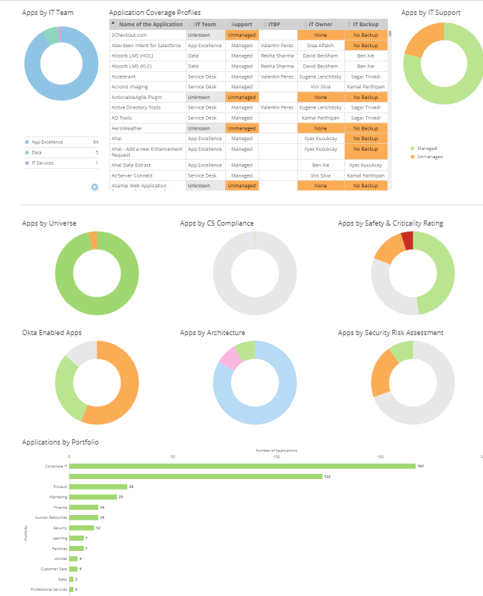

1. Applications by IT teams

Rationale

The card is designed as a pie chart to depict small number of IT teams. The pie chart is based on IT teams with each pie value is based on the count of applications falls under each IT team. The pie chart can have 60 slices at most and it is following a common color convention like other cards.

Interpretation

The card gives an insight about the applications falls under different IT team and the managers will be able to count the number of applications in each team and which team has the highest share of applications.

1. Application backup

Rationale

A mega table has been used to represent the categorical data of three columns. It provides the functionality of scroll bar which enables the user to scroll through the list of applications with respective app owners and the person responsible as a backup for that application. The blanks value in the backup column is replaced with “No backup” with the help of a calculated field called “Application Backup”. Another calculated field used in the card is “application owner” which replaces the black value in the app owner column with None. The table is sorted by application name in an alphabetical order.

Interpretation

The table can be filter by application and applications which gives an insight to the user that which application do not have any backup and who is the app owner for such applications or which applications do not have any application owner as well.

1. Applications by Architecture

Rationale

A tree map has been used to designed the card to show the number of applications by the Architecture. The big rectangle represents the Architecture which is further classified into sub categories. The size of each sub category represents the number of application based on the architecture type.

Interpretation

The card has two filters which allows the user to filter the applications by Architecture along with the count of application belongs to a particular architecture and vice versa.

1. Applications by IT Business Partner

Rationale

Based on the limited size of IT business partner, a pie chart based on the IT Business partner is designed which represents various IT partners of applications. The slice of the pie chart is 50 hence, 50 or less than this number of IT partners can be added to the pie chart. The pie chart value is the count of applications falls under each IT business partner.

Interpretation

The card allows a user to see the count of application by IT Business Partner with a flexibility to see the applications belong to IT partners.

1. Managed vs unmanaged Applications

Rationale

The total number of applications are divided into three categories managed, unmanaged and tools which are represented by a donut chart. Each pie value represents the number of applications falls into any of the above mentioned categories.

Interpretation

The card gives an insight about the applications and its size corresponded to any of the three categories i.e. managed, unmanaged and tools.

1. Security Risk Assessment

Rationale

The pie chart is designed to represent whether an application has a record of security risk assessment or not. The pie value depicted the count of yes and no.

Interpretation

The card is filtered by the application name which allows the user to see if an application has a security risk assessment completed or not. It also allows the user to drill down the applications having security risk assessment to check their assessment links as well.

1. Single sign on enable applications

Rationale

A pie chart is used to represent the categorical data i.e. Yes, or No.

Interpretation

The chart allows the user to check whether an application is single sign on enable by Okta or not. The card is filtered by the application name to check the SSO enable status of the application individually or in a group. It is also used to count the number of application having security risk assessment completed or not.

1. Applications by Portfolio

Rationale

A horizontal bar chart is used to see the descending order of the size of applications corresponding to the various Portfolios.

Interpretation

The chart is filtered by application which give a user the flexibility to see the various applications corresponds a portfolio by drilling down the card further. In addition, the user can see the total number of applications belongs to each portfolio which is sorted in descending order.

Financial Data by applications Jan-Nov

The dashboard has a common filter called month label applied to all the cards which helps to filter the amount spend on applications on a monthly basis.

1. IT spend by department

Rationale

A horizontal bar chart is used to see the amount of money spends by each department which can be filtered by support and spend type. The bar chart is arranged in the descending order to view the maximum to the minimum spending by department.

Interpretation

The bar chart allows the user to see the highest amount spend by department, which is further classified on basis of spend type. There is a total of the amount spend by the department displayed at the end each bar. Also, when hover over the spend type, it displays the total amount spend by the spend type as well. Two filter are added to the horizontal bar chart which gives the user an opportunity to filter the data based on any spend type and any type of support. The summary displays the sum of the amount spend by the department.

2. IT spend by support

Rationale

To represent the three categories of support type, a donut chart has been used. Each donut slice has a value equal to the sum of the amount spend by the type i.e. known, unknown and N/A.

Interpretation

The donut chart allows the user to understand the sum of amount spend by support type which can be filter by application name s well.

3. IT spend by applications

Rationale

A horizontal bar graph is used to display the amount spend by each application in the descending order.

Interpretation

The chart represent the amount spend by each application. The summary at the tops allows the user to understand the sum of the amount spend by applications and the highest to the lowest amount spend on the applications.

3. Conclusion:

By working on the domo report at Kinaxis, I gained skills in SharePoint, Domo and Excel. This internship has really helped me to improve my soft skills as well such as communication and presentation skills. Overall, I become more professional as a person because of the experience I gained from Kinaxis by working with professional Business Analyst and Business managers.

***Appendices***

Fig 1.0

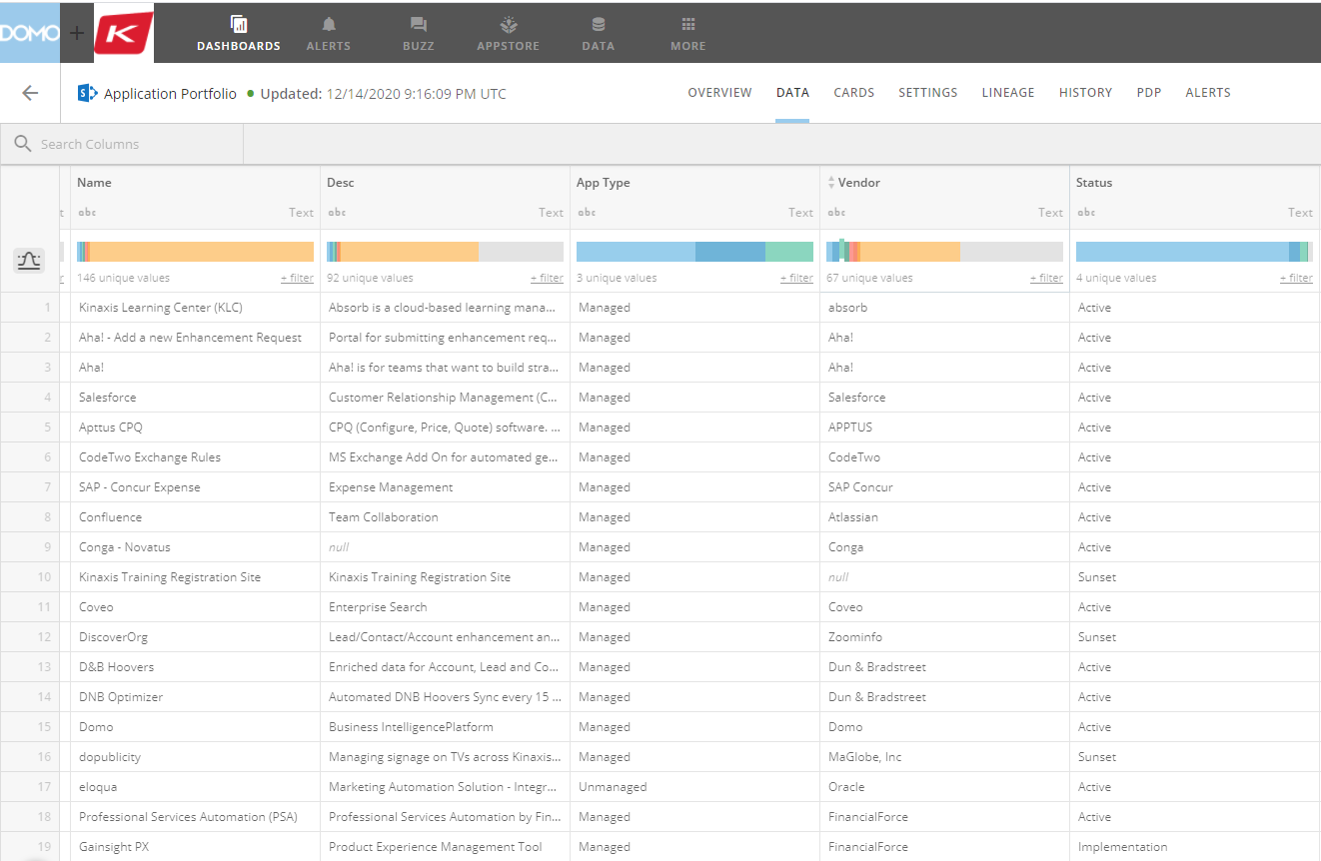

Fig 2.0

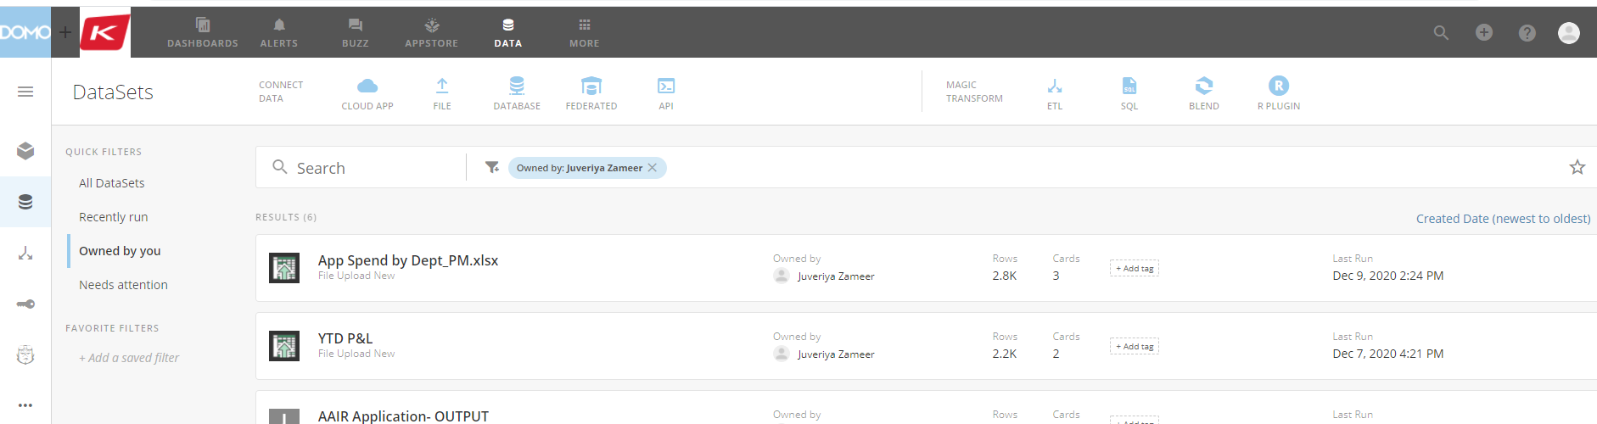

Fig 3.0

